EPIC in The European Platform for Investing in Children: http://ec.europa.eu/social/main.jsp?catId=1246&langId=en.
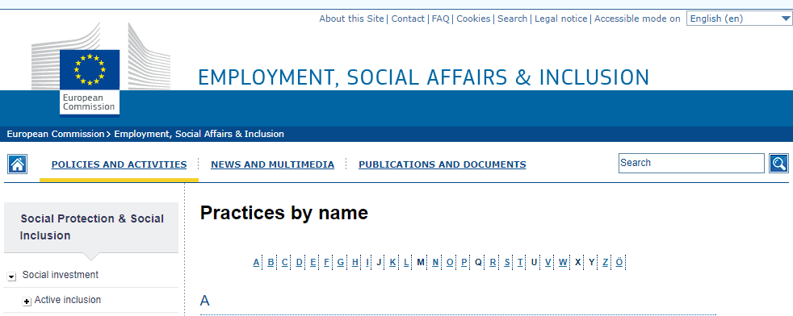
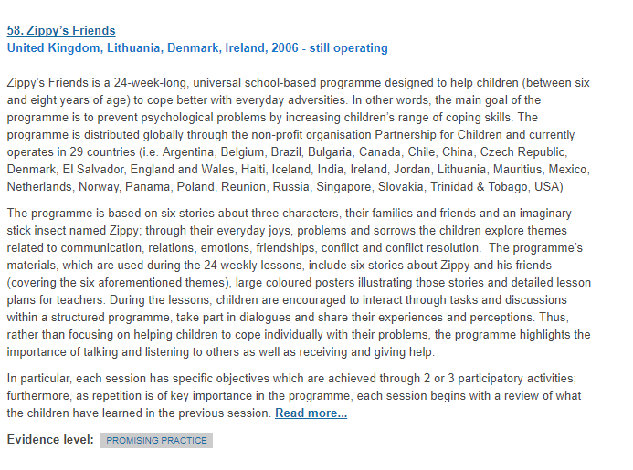
The entry on Zippy’s Friends is at http://ec.europa.eu/social/main.jsp?catId=1251&langId=en&mode=1#chapter_Z
WHO: ZIPPY’S FRIENDS programme is featured in two WHO publications:
- WHO and World Federation for Mental Health, Mental Health Promotion: Case Studies from Countries, ed. Shekhar Saxena and Preston J Garrison (2004) pp 102-104;
- WHO, Promoting Mental Health: Concepts, Emerging Evidence. Practice, ed. Helen Herman, Shekhar Saxena and Rob Moodie (2005) pp269-270.
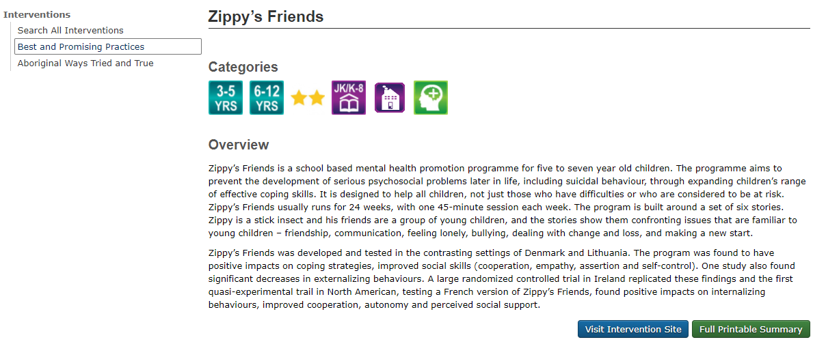

The entry on Zippy’s Freinds is at http://cbpp-pcpe.phac-aspc.gc.ca/interventions/zippys-friends/

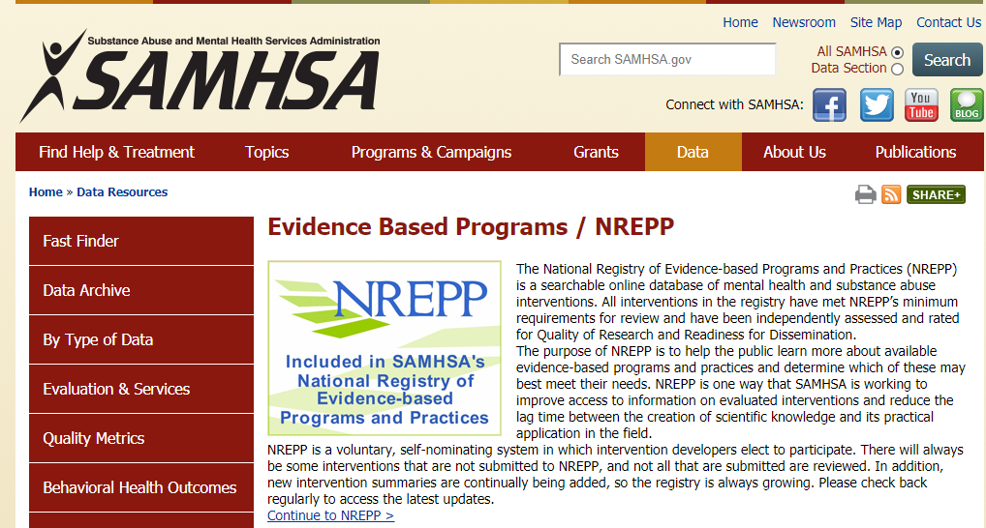

The entry for Zippy’s Friends is at http://legacy.nreppadmin.net/ViewIntervention.aspx?id=271; currently under re-review.

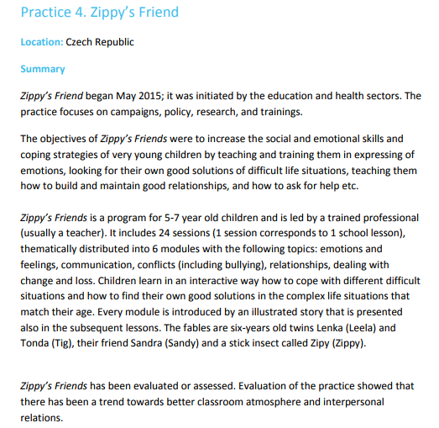
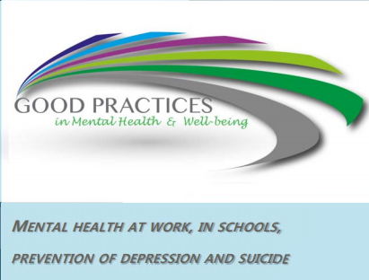

The entry for Zippy’s Friends is at page 14; https://ec.europa.eu/health/sites/health/files/mental_health/docs/2017_mh_work_schools_en.pdf

