Partnership for Children - International Workshop 2016 Report
Introduction
The Fourth International Workshop, which ran from 21st – 24th March 2016, was a wonderful event, and it was great to have so many colleagues gathered together to share ideas, to network, and to present their recent work. One delegate said:
“Every delegate I spoke to was deriving huge benefit from it, and I'm sure, like me, they were impressed, excited and inspired. I personally learned an enormous amount and am looking forward to putting that to good use as we look to the future of our important work.”
Partnership for Children manages two very successful mental health promotion programmes for children. Our current programmes Zippy’s Friends and Apple’s Friends are running in kindergartens and schools in 30 countries and have already helped more than 1,250,000 children. Our programme for children with special needs is soon to be launched and we hope to add more programmes to our suite - we heard more about these new programmes at the International Workshop.
Many of the key people responsible for that success gathered at Keble College, Oxford, to share their experiences and discuss what more they could do to promote children’s mental health. The Fourth International Workshop attracted 58 delegates from 21 countries, and we were delighted that this was the first time that many of our UK partners took part. Delegates’ feedback confirmed that they all found it relevant, useful and motivating. The average score on our evaluation forms was 4.7 out of 5.
This report is a brief summary of the discussions that took place. It is not intended to be a comprehensive or chronological record. All the PowerPoint presentations and videos shown over the four days have been uploaded to a dropbox here: https://www.dropbox.com/sh/8mvxewdc5jpdq79/AAAMl9YGEZTmb3GbJUeDA_Wca?dl=0. We will add a PDF of the Partners around the World booklet and the photographs to the dropbox.
This event would not have been possible without the generous support of four sponsors, The Providence Foundation from Hong Kong, and three private individuals. We are extremely grateful to all of them for their kindness and support, and thank them once again.
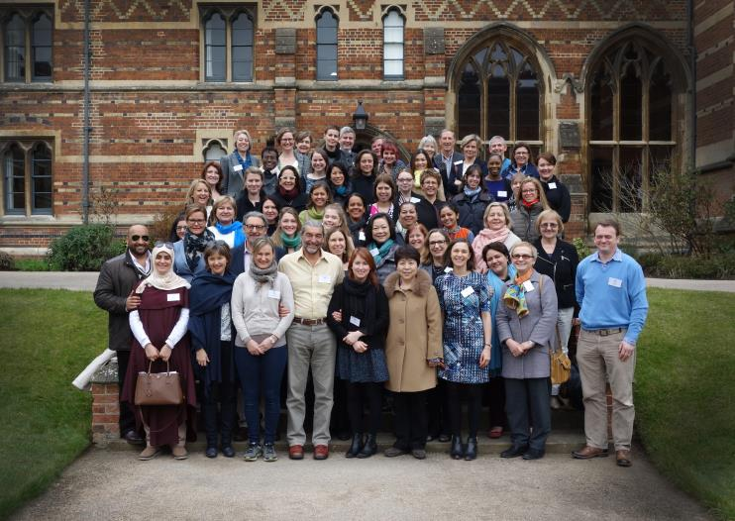
Fourth International Workshop, 21st – 24th March 2016
Keble College, Oxford

The Programme
The programme for this year’s workshop covered many different aspects of our work – from the origins of Zippy’s Friends 20 years ago through to the latest developments in digital technology.
We were delighted that Dr. Dora Guðmundsdóttir, Director of Determinants of Health and Wellbeing at the Directorate of Health in Iceland, gave the keynote address on ‘Helping Children to Flourish’. Dora is a governmental expert on mental health and National Focal Point for the EU Health Programme, and presented her research on the impact of economic strength on the happiness and mental wellbeing of children. It was fascinating to hear that her research showed that adolescents’ happiness increased after the economic crash in Iceland, when parents were able to spend more time with their children. She also said:
“If we wait until we have fixed all the mental health disorders, we will never get around to promoting health.”
The theme of the first day was Past, Present and Future, starting with a presentation by Professor Mette Ystgaard on how Zippy’s Friends began 20 years ago with a team of academic advisors, and the process of development, from first educational principals to the effective and popular programme that runs today.
We heard from the team at Partnership for Children about our updated programme materials, including the revised Zippy’s Friends resources, the Inclusion Supplement, and Apple’s Friends. We heard about a new large-scale Randomised Control Trial (RCT) evaluation study in the UK, with a presentation on its research methods from our colleagues at Queen's University Belfast.

Dr. Biza Stenfert-Kroese discussed the difficulties and successes of the small-scale feasibility evaluation conducted by Birmingham University on the Special Needs Supplement, and resources for older pupils studying in special schools. Partnership for Children announced that the resources, once they have incorporated suggestions by Birmingham University, will be released to partners in the summer.

Later that day, we heard about how we hope to use technology, devices and apps to strengthen our programmes in the classroom, at home, and between teachers. We had interesting discussions about the differing amounts of technology in homes and schools around the world, across our different partners.

Finally, we heard about regional management of our partnership model as it expands. Coral De La Zerda, our Latin American coordinator, presented the very successful regional workshop she ran at the end of 2015. We used technology to link with our Middle Eastern and North African coordinator, Amani Attili, who is beginning to spread the programme to Arabic speaking countries, beginning in Jordan and Kuwait. Sadly, Amani was not granted a visa in time to join us. We hope that more regional coordinators will be in place over the next few years, to build and strengthen our model.

There was an exhibition space with displays from every country, and in the coffee breaks, partners had a chance to share experience and swap information with others from around the world.
The theme of the second day was Involving the Whole School, and began with a presentation by Dr Aleisha Clarke on the importance of the Whole School Approach, and the findings of her research, showing what works and what doesn’t. We heard how essential head teachers’ commitment is, and that if we integrate emotional health promotion into everyday practice in schools, along with involvement of families and the wider community, we will achieve a more significant impact.
The latest programme made available to all partners is Apple’s Friends and we heard from four partners who are using the programme in their countries: the Netherlands, with the evaluation by the Trimbos Institute; Brazil, with an impressive 33,579 children to date enrolled in the programme; Lithuania, with 14,389 children and 674 teachers involved; and China, with 8 cities and nearly 8,000 children using the programme. We also saw a delightful video of Chinese schoolchildren singing an Apple’s Friends song.
Professor Brian Mishara from Canada presented a programme for children aged 9-11, Passport: Skills for Life. The programme is built on the same principles and objectives as Zippy’s Friends and Apple’s Friends, while using a completely different style; 17 sessions, with black and white comic strips, about a dragon and his adventures with two children.
The afternoon was focused on Zippy at Home, involving parents and families; how partners have done this in Brazil, with a staggering 7,780 parents; in Mauritius, where attending the sessions had transformed parents’ attitudes; and in Newcastle, UK, with hard to reach parents. Later, small groups got creative and designed parent activities.
Caroline Egar, our Programme Director, summarised the results of a survey conducted by Partnership for Children last year, where partners had told us about obstacles and achievements in engaging whole school communities and advocating more widely for mental health promotion.
We said farewell to our previous Director Chris Bale who retired in February, and to Caroline Lifford who will be leaving after five and a half years as our Programme Manager. Some tears were shed, lovely songs sung, and gifts presented. The day finished with a lively evening at an ancient barn in the Oxfordshire countryside, where our artistic skills were unleashed in decorating handkerchiefs, we learnt about local folk lore, and danced enthusiastically alongside traditional Morris Dancers.
During the workshop, every partner presented a brief Success Story from their country or region, including:
- Two Norwegian boys who were standing red-faced in the playground, with their fists balled; when asked what they were doing, they said they were ‘trying to find a good solution’!
- An oncology department in Chile which used Zippy’s Friends with terminally ill children, giving them the vital confidence and space to talk about their feelings.
- A Russian teacher who used coping principles when her husband let her cat out during their house move, and it got lost. The cat returned!
- A child in Kuwait who was able to talk about the death of his father for the first time.
The theme of the final half day was Inspiration! We began by hearing about SPARK, a programme aimed at 10-12 year-olds which uses the concepts of cognitive behaviour therapy to help children understand how they perceive situations and to build resilience. The programme has undergone relatively small trials in various countries around the world including Japan, and we hope to work with its creator, Dr Ilona Boniwell, to expand it more widely.
The workshop closed with an incredibly touching and personal insight into the importance of our work from Dick Moore, a former head teacher and rugby coach. He told us about his son, who tragically took his own life in his early 20s, unable to cope with the difficulties that life threw at him. The room was silent as Dick explained that perhaps, if his son has received one of our programmes to boost his coping skills, things might have turned out differently. Dick finished with the thought:
“Life is not about waiting for the storms to pass, it is about learning to dance in the rain.”
Delegates’ feedback forms showed that they felt their three days at Keble College had been well spent. One wrote: “The workshop was excellent: to connect with other partners, hear about new input and the latest research.”

Thank you to everyone who took part in the Fourth International Workshop. See you next time!

