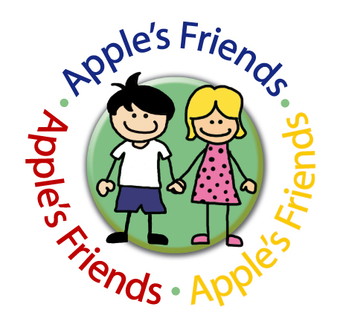
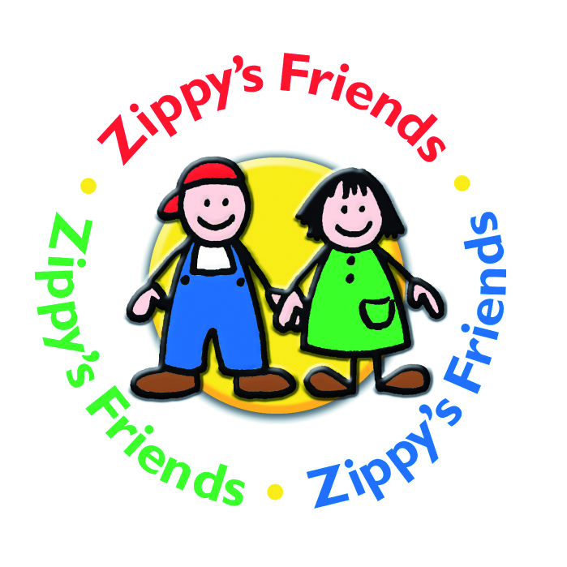
An evaluation of the Zippy’s Friends and Apple’s Friends programmes
by
The Trimbos Institute, the Netherlands (2016)

A comprehensive evaluation of the Zippy’s Friends programme has recently been carried out in the Netherlands by the Trimbos Institute. Using a cluster randomised controlled trial, this study sought to determine the impact of Zippy’s Friends on children’s (i) social and emotional skills (ii) internalising and externalising behaviour and (iii) academic achievement. The programme was evaluated with schools with a high percentage of children from families with a low socioeconomic status (as measured by the education level of the parents). In addition to examining the impact of the Zippy’s Friends programme with this group of children, the study also sought to determine if programme outcomes were associated with ethnicity, gender, age, urban location and school factors including social climate, class composition and programme fidelity.

Methodology
Sample
A total of 29 schools (1,177 children) took part in this study. Children in Group 3 and 4 (age 6 and 7) were randomly assigned to the intervention (N = 586) or control (N = 591) condition.

Data Collection
The evaluation study was conducted between September 2012 and July 2014. Over the course of the two year study period, children in Group 3 received Zippy’s Friends in year 1 and again the following year. Children in Group 4 received Zippy’s Friends in year 1. The following year, this group of children received Apple’s Friends. This programme consists of 26 lessons and is designed as a follow on programme to Zippy’s Friends.

Data was collected at three time points: (i) pre-intervention – prior to taking part in the programme (ii) post-intervention - upon completion of the Zippy’s Friends programme and (iii) 12 months later – upon completion of Apple’s Friends.

Measures
Data was collected from children, teachers and parents at all three time points. Five measures were used to determine the impact of the programme on children’s social and emotional skills. The children completed two measures, including: Levels of Emotional Awareness for Children (LEAS-C, Bajgar & Lane, 2004) and Social Information Processing Scale (SIP, Orobio et al., 2005). Both standardised measures were based on scenarios / vignettes which were read to the children individually. Teachers and parents completed the Emotional Literacy Checklist (ELC, Faupel, 2003) and Head Start Competence Scale (HSCS, Domitrovich et al., 2001). The teachers completed a third social and emotional skills measure, Preschool and Kindergarten Behaviour Scales (PKBS, Merrel, 1996). Internalising and externalising behaviour problems were measured by the teachers and parents using the second part of the Preschool and Kindergarten Behavior Scales (PKBS, Merrell, 1996). Academic achievement was measured using the Cito literacy and numeracy scores which are carried out twice a year in the Netherlands.

Data analysis
Multilevel analysis, which controlled for clustering at the class level, was used to determine the impact of the programme over the course of the two year study period.

Results
The average age of the children in the sample at the baseline was 6.9 years. Just over half of the sample (51%) were girls and 49% were boys. Almost half of the children (48.5%) were of immigrant origin (at least one parent born outside of the Netherlands) and 41% had a non-Western origin (at least one parent born outside Europe).

Quality of implementation
During the first year of the study, teachers maintained a Zippy’s Friends logbook which provided information on programme fidelity for the 24 lessons. In total 20 logbooks (69%) were returned. The results from the logbook were recoded with ‘well implemented’ indicating that at least three of the four lessons within this module were completed. As can be seen in Table 1, Modules 1-3 were ‘well implemented’ by 75% of the teachers. Fidelity was considerably lower for modules 5 and 6.

Table 1: Programme implementation for each module (N = 20 teachers)

 | Well implemented | Not well implemented
Module 1 | 75% | 25%
Module 2 | 75% | 25%
Module 3 | 75% | 25%
Module 4 | 65% | 35%
Module 5 | 40% | 60%
Module 6 | 30% | 70%
Module 1-6 | 60% | 40%

In addition to teachers’ reports, Ms. Marion Panis, the coordinator of the programme in the Netherlands observed one lesson in every Zippy’s Friends class (N = 29). Results from these observations indicated that the majority of lessons were implemented with high fidelity. Only one of the observed lessons was determined to be ‘insufficient’ based on the manual instructions.

Programme effectiveness

Social and Emotional Skills
Results from the children’s self-report measure Levels of Emotional Awareness for Children (LEAS) revealed participants in the intervention group scored significantly higher on emotional recognition compared with participants in the control group (β= 2,86; SE= 1,14; p= 0.01). Results from the Social Information Processing Scale (SIP), which was also completed by the children, indicated a significant programme effect in relation to improved ‘adaptive coping’ (problem solving coping skills) among participants in the intervention group (β = 0.14; SE = 0.04; p = 0.00).
In addition to these programme effects as measured by the children, results from the parent measures indicate a significant improvement in the intervention group’s social and emotional skills. Specifically, analyses of the parent-completed Emotional Literacy Checklist revealed children in the intervention group had a significantly higher ‘Total Emotional Literacy’ score when compared with children the control group (β= 2.07; SE= 0.85; p= 0.01). Subscale analyses showed significant improvements in participants’ ‘Motivation’ score as a result of the programme (β= 2.07; SE= 0.85; p= 0.01).
Results from the teachers’ measures revealed that there was no significant difference between intervention and control groups’ social and emotional skills.

Internalising and Externalising Behaviour:
Analyses of the parent measure, Preschool and Kindergarten Behavior Scales (PKBS) indicated a significant reduction in children’s externalising problem behaviour (β= -2.12; SE= 1.11; p= 0.05). Children in the intervention group evidenced a significant reduction in inattention / hyperactive behaviour (β= - 0.92; SE= 0.42; p= 0.03) and antisocial / aggressive behaviour (β= -0.75; SE= 0.32; p= 0.02). There was no significant effect on the subscales egocentric / explosive behaviour and internalising behaviour. Results from the same questionnaire completed by the teachers revealed no significant difference between the intervention and control groups internalising and externalising scores. Additional subgroup analyses using this measure could be interesting in terms of examining the impact of the programme with the most ‘at risk’ children i.e. children with increased internalising or externalising behaviour.

Academic Achievement
Zippy’s Friends did not have a significant impact on children’s academic achievement as measures by the Cito literacy and numeracy scores. As stated by Trimbos, the short study period is a possible explanation as to why no programme effect was found.

Subgroup Analyses
Subgroup analyses revealed that there was no clear relationship between the effect of Zippy’s Friends and ethnicity, gender or the educational level of parents. Regarding impact of school conditions, there was no significant interaction between programme outcomes and classroom climate, class composition or programme integrity.

Subgroup analyses did, however, reveal that the programme was more effective among participants aged 7 (children that received Zippy’s Friends and Apple’s Friends) than participants aged 6 (children who received Zippy’s Friends twice). Based on parent and teachers scores, children in the intervention group aged 7 showed more of an improvement in social emotional skills (subscales: Self-awareness, Self-regulation, Motivation, Social skills, Emotional regulation) and problem behaviour (subscales: Social cooperation, Social skills, Ego-centric/explosive behaviour, Attention problems/overactive behaviour, Externalising problems) when compared with children aged 6. Trimbos Institute states that the children in this study with low socioeconomic status may lag behind in their social emotional development, which may indicate that they are not ready for Zippy’s Friends classes at age 6, and thus cannot benefit as much from the lessons. The results provide some indication that either (i) Zippy’s Friends is more effective with older children and/or (ii) Zippy’s Friends is more effective when implemented in combination with Apple’s Friends as opposed to children receiving Zippy’s Friends twice.

Summary of Findings
Overall, the results from this study are positive with both child self-report and parent report measures revealing a significant positive impact on children’s social, emotional and behavioural outcomes. Whilst teacher reports did not show significant programme findings, results from the child-self report measures indicated a significant improvement in children’s emotional recognition skills and adaptive coping skills. In addition, parents also reported an improvement in children’s social emotional skills, in particular, enhanced motivation and reduced externalising behaviour problems including hyperactivity and aggressive behaviour. Trimbos Institute states that these positive findings reported by parents are important given that some researchers argue that parents are better informants than teachers because they observe children in multiple settings (Berg-Nielsen et al., 2012).

This study shows that Zippy’s Friends has a positive effect on social emotional competencies and behavioural problems for children from families with low socioeconomic status. This confirms that taking part in Zippy’s Friends enhances children’s social and emotional development.

Subgroup analyses revealed that Zippy’s Friends had more of an effect on children aged 7 who received both Zippy’s Friends and Apple’s Friends compared with children aged 6 who received Zippy’s Friends programme twice. The programme was not shown to have an impact on academic performance, although the short study time period should be taken into account when interpreting this finding.

The results from this study support the findings from previous evaluations of Zippy’s Friends. This is the third large scale evaluation of Zippy’s Friends using a randomised controlled trial. Results from the previous two studies carried out in Norway (Holen et al., 2012a,b) and Ireland (Clarke et al., 2014a,b) revealed a significant improvement in children’s coping strategies (Holen et al., 2012a, Clarke et al., 2014b), emotional literacy skills including self-awareness, self-regulation, motivation and social skills (Clarke et al., 2014a) and significantly reduced mental health difficulties (Holen et al., 2012a). Results from the Irish study indicated that that the significant positive impact of the programme on children’s emotional literacy skills was maintained at 12 month follow up (Clarke et al., 2014a). Broader findings from the study conducted in Norway included improved social climate in the classroom, reduced bullying and improved academic behaviour (Holen et al., 2012b). The results from this current study carried out in the Netherlands provide additional insight into the effectiveness of Zippy’s Friends from the perspective of the children and the parents. In addition, this if the first study to include Apple’s Friends as part of its evaluation with promising results pointing to the need for further investigation into the combined effectiveness of Zippy’s Friends and Apple’s Friends.

References
Bajgar, J. & Lane, R. (2004). The Levels of Emotional Awareness Scale for Children (LEAS-C): Scoring Manual Supplement. Wollongong, Australia: University of Wollongong, Illawarra Institute for Mental Health.

Berg-Nielsen, T. S., Solheim, E., Belsky, J. & Wichstrom, L. (2012). Preschoolers’ Psychosocial Problems: In the Eyes of the Beholder? Adding Teacher Characteristics as Determinants of Discrepant Parent–Teacher Reports. Child Psychiatry & Human Development, 43, 393-413. doi: 10.1007/s10578-011-0271-0.

Clarke, A.M., Bunting, B., & Barry, M.M. (2014). Evaluating the implementation of a school-based emotional wellbeing programme: a cluster randomised trial of Zippy’s Friends for children in disadvantaged primary schools. Health Education Research, 29(5), 786–798.

Clarke, A.M., Sixsmith, J., & Barry, M.M (2014). Using participatory approaches to evaluate the implementation of an emotional wellbeing programme for primary school children. Health Education, 74(5), 578-593.

Domitrovich, C.E., Cortes, R.C. & Greenberg, M.T. (2001). Head Start Competence Scale Technical Report. Unpublished manuscript, Pennsylvania State University.

Faupel A. Emotional Literacy: Assessment and Intervention—Ages 7 to 11. London: nferNelson, 2003.

Holen S, Waaktaar T, Lervag A, Ystgaard M. The effectiveness of a universal school-based programme on coping and mental health: a randomised, controlled study of Zippy’s Friends. Educational Psychology. 2012; 32(5): 657-677.

Holen S, Waaktaar T, Levag A, Ystgaard M. Implementing a universal stress management program for young school children: are there classroom climate or academic effects. Scandinavian Journal of Educational Research. 2012; 1-25.

Merrell, K. W. (1996). Socio-emotional assessment in early childhood: The Preschool and
Kindergarten Behavior Scales. Journal of Early Intervention, 20, 132–145. doi:10.1177/105381519602000205.

Mishara B, Ystgaard M. Effectiveness of a mental health promotion program to improve coping skills in young children: Zippy's Friends. Early Childhood Research Quarterly. 2006; 21(1): 110-123.

Orobio de Castro, B. O., Merk, W., Koops, W., Veerman, J. W. & Bosch, J.D. (2005). Emotions in social Information processing and their relations with reactive and proactive aggression in referred aggressive boys. Journal of Clinical Child & Adolescent Psychology, 34, 105–116. doi:10.1207/s15374424jccp3401_10.

Report produced: February 2016

